Tutorial – 10.1

**Aim:** write a shell script which receives any year from the keyboard and determines whether the year is leap year or not. If no argument is supplied the current year should be assumed.

**Code:**Echo “Enter Year:”

read y

year=$y

y=$(( $y % 4 ))

if [ $y -eq 0 ]then

echo "$year is Leap Year!"

else

echo "$year is not a Leap Year!"

fi

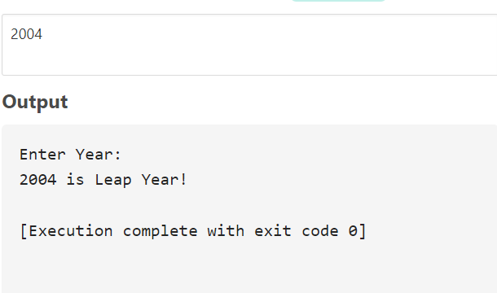**Output:**